Persona Description: The behaviour under focus relates to the use and disposal of plastics in the Australian society. The need for change concerns adoption of ecofriendly habits to reduce plastic waste and ease the effects on marine life (entanglement or ingestion) and the overall harm to the environment. The macro target for this project/campaign would be the ideal office worker. Office workers contribute significantly to the plastic pollution through the use and disposal of plastic water bottles and plastic food containers among others. A focus on this segment would be ideal in the objective of raising sensitization and behaviours change in favour of reduced plastic pollution. In an effort to improve the outlook of the Australian waste statistics, a focus on the persons in the corporate world would be relevant and fruitful in the campaign.
Empathy Map: (Attached, separately)

- Portrait Image:
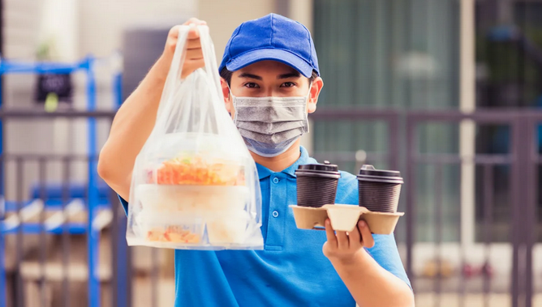

- Name: Charlotte Lewis

- Demographic Information:
- 29 year old, female, single mother of one.
- Works in an actuarial firm in Brisbane.
- Lives in suburban area of Moreton Bay, Brisbane.
- Passionate about diet, regularly orders food while at work.
- At home, prefers ordering as well, over cooking.

- Quotes: Charlotte is a contemporary corporate woman who has a good work-life balance. She is digitally connected and aware of contemporary news events including climate change and pollution. She does not believe enough is being done to reverse effects of plastic pollution but is much willing to take part in making the environment safe and healthy for all.

- Mood images:

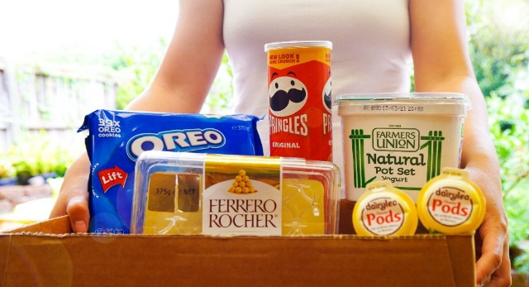

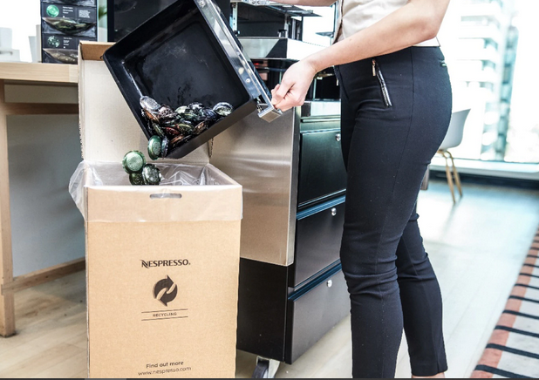

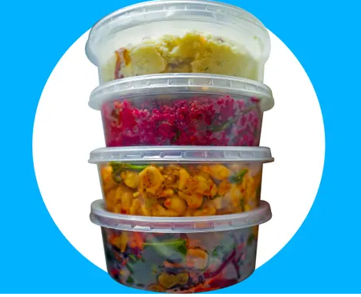

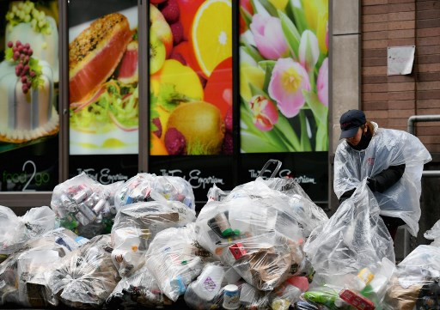

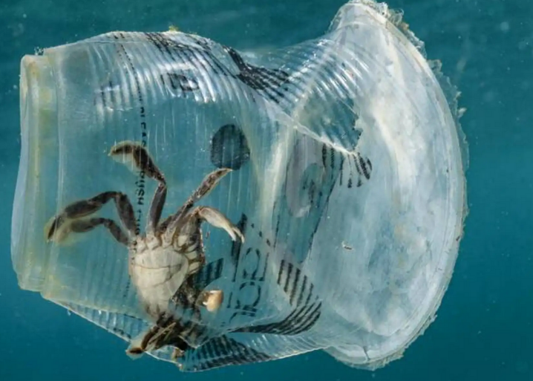
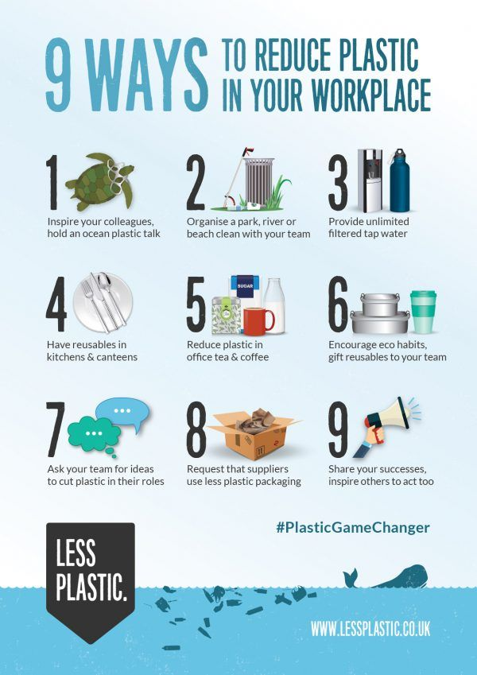

- Description:
- The persona has low consciousness about the pollution rates and effects of plastic pollution in Australia.
- However, they are tech-savvy and have good digital connection such supports lifestyles such as food ordering.
- They use plastics dominantly in food packaging and consumption at large.
- They are not keen on adopting practices that reduce plastic pollution.
- They recognise some efforts including advocacy to reduce pollution.
- They do not believe such efforts are enough to ensure a healthy environment.
- They show optimism to adopt eco-habits that reduce plastic pollution, if supportive initiates were in place.
- They are uncertain how day-to-day living would be with reduced plastic use.

- Statistics:
- Australians buy more than 118,000 tonnes of plastic drink bottles and over 5 million plastic packaging containers a year.
- Only 36% of plastic drink bottles get recycled, with 373 million plastic bottles ending as waste.
- The national recycling rate is less than 10% (9.4%) according to the annual Australian Plastics Recycling Survey
- 'Single-use plastics' to be phased out in Australia from 2025
- 9 in 10 Australians are concerned about environmental sustainability.
- 3 in 10 employees are conscious about eco-habits
- The rise of eco-friendly workplaces has been estimated to increase by 20% in the past decade.

